A Systematic Meta-Analysis of Rumen-Protected Choline Supplementation on Ruminant Performance and Health Outcomes
Lily Liu ^{a, b#}, Weiqi Wang ^{a#}, Yajin Yang ª, Qin Zhang ^{c*}, Jinhai Wang ^{b, d*}
ª College of Biological and Food Engineering, Southwest Forestry University, Kunming 650224, PR China
^{b} The Roslin Institute, University of Edinburgh, Edinburgh, EH25 9RG, UK
^{c} College of Animal Science and Technology, Shandong Agricultural University, Tai’an 271018, PR China
^{d} College of Animal Science and Technology, Northwest A&F University, Yangling 712100, PR China

*Correspondence author: Jinhai Wang; Qin Zhang
Email: jzw0173@auburn.edu (J, Wang); qzhang@sdau.edu.cn (Q, Zhang)

Table S1. Overall effect size calculation outcomes and the results from moderator analysis for growth, blood metabolites, production, liver composition, immunity and gene expression. (SMD, standardized mean difference; k, the number of effect sizes for each level of moderators; CI, confidence interval; PI, predicted interval)

Response variables | Subgroup | K | SMD  (Hedges'g) | SE | I² % | 95% CI |  | P-value | 95% PI
 |  |  |  |  |  | lower | upper |  | lower | upper
Growth
Overall |  | 95 | 0.33 | 0.18 | 81.90 | -0.03 | 0.69 | 0.07 | -1.60 | 2.26
Parameter | FCR | 9 | 0.06 | 0.38 |  | -0.67 | 0.80 |  | -1.67 | 1.80
 | DMI | 45 | 0.15 | 0.23 |  | -0.20 | 0.49 |  | -1.47 | 1.76
 | BCS | 13 | 0.24 | 0.37 |  | -0.39 | 0.88 |  | -1.45 | 1.94
 | ADG | 29 | 0.45 | 0.22 |  | 0.00 | 0.89 |  | -1.19 | 2.08
Species | Sheep | 43 | 0.78 | 0.41 |  | 0.14 | 1.42 |  | -1.22 | 2.79
 | Goats | 13 | 0.20 | 0.52 |  | -0.70 | 1.11 |  | -1.90 | 2.31
 | dairy cow | 39 | 0.10 | 0.25 |  | -0.39 | 0.59 |  | -1.86 | 2.06
Period | Growth | 49 | 0.35 | 0.25 |  | -0.15 | 0.85 |  | -1.32 | 2.02
 | Prepartum | 35 | 0.16 | 0.33 |  | -0.27 | 0.60 |  | -1.49 | 1.82
 | Postpartum | 11 | 0.18 | 0.43 |  | -0.50 | 0.86 |  | -1.55 | 1.92
Production
Overall |  | 125 | 0.49 | 0.19 | 88.74 | 0.10 | 0.88 | 0.01 | -1.75 | 2.74
Parameter | DMI | 5 | 0.55 | 0.48 |  | -0.39 | 1.50 |  | -1.43 | 2.54
 | ECM | 8 | 1.30 | 0.52 |  | 0.56 | 2.05 |  | -0.59 | 3.20
 | MFP | 19 | 0.61 | 0.51 |  | 0.12 | 1.11 |  | -1.20 | 2.43
 | MFY | 15 | 0.51 | 0.48 |  | -0.02 | 1.05 |  | -1.31 | 2.34
 | MLP | 5 | 0.09 | 0.62 |  | -0.78 | 0.95 |  | -1.86 | 2.03
 | MLY | 5 | -0.40 | 0.62 |  | -1.26 | 0.46 |  | -2.34 | 1.55
 | MPP | 18 | 0.26 | 0.51 |  | -0.25 | 0.76 |  | -1.56 | 2.07
 | MPY | 17 | 0.04 | 0.48 |  | -0.46 | 0.55 |  | -1.78 | 1.86
 | MSP | 2 | 0.28 | 1.03 |  | -1.53 | 2.10 |  | -2.24 | 2.80
 | MUN | 11 | 0.27 | 0.55 |  | -0.37 | 0.92 |  | -1.59 | 2.13
 | MY | 27 | 0.67 | 0.49 |  | 0.23 | 1.11 |  | -1.13 | 2.47
 | SNFP | 2 | 0.69 | 1.02 |  | -1.12 | 2.49 |  | -1.83 | 3.20
Species | Dairy cow | 102 | 0.47 | 0.24 |  | -0.01 | 0.95 |  | -1.83 | 2.78
 | Goats | 22 | 0.55 | 0.45 |  | -0.2 | 1.29 |  | -1.83 | 2.92
Period | Prepartum | 106 | 0.42 | 0.45 |  | -0.40 | 1.24 |  | -1.59 | 2.43
 | Postpartum | 18 | 0.45 | 0.41 |  | 0.08 | 0.83 |  | -1.42 | 2.33
Blood metabolites
Overall |  | 295 | -0.06 | 0.06 | 66.86 | -0.19 | 0.07 | 0.38 | -1.19 | 1.07
Parameter | ALB | 11 | -0.17 | 0.26 |  | -0.69 | 0.35 |  | -1.38 | 1.04
 | ALP | 9 | -0.46 | 0.37 |  | -1.03 | 0.11 |  | -1.69 | 0.78
 | ALT | 14 | 0.34 | 0.33 |  | -0.11 | 0.79 |  | -0.84 | 1.52
 | AST | 20 | -0.19 | 0.30 |  | -0.54 | 0.16 |  | -1.34 | 0.95
 | Betaine | 9 | -0.19 | 0.37 |  | -0.71 | 0.34 |  | -1.40 | 1.02
 | BHB | 47 | -0.18 | 0.28 |  | -0.40 | 0.04 |  | -1.30 | 1.93
 | BUN | 23 | -0.42 | 0.29 |  | -0.72 | -0.11 |  | -1.55 | 0.72
 | Cholesterol | 37 | -0.12 | 0.28 |  | -0.38 | 0.13 |  | -1.25 | 1.00
 | Glucose | 53 | 0.09 | 0.27 |  | -0.12 | 0.30 |  | -1.02 | 1.21
 | HDL | 14 | -0.13 | 0.33 |  | -0.56 | 0.31 |  | -1.31 | 1.05
 | Insulin | 14 | 0.20 | 0.34 |  | -0.23 | 0.63 |  | -0.97 | 1.38
 | LDL | 14 | 0.34 | 0.33 |  | -0.11 | 0.79 |  | -0.84 | 1.52
 | PC | 5 | 0.54 | 0.42 |  | -0.12 | 1.21 |  | -0.71 | 1.83
 | TAG | 25 | -0.11 | 0.29 |  | -0.42 | 0.19 |  | -1.25 | 1.03
 | TP | 11 | -0.24 | 0.34 |  | -0.74 | 0.26 |  | -1.44 | 0.96
 | VLDL | 5 | 0.86 | 0.47 |  | 0.09 | 1.64 |  | -0.48 | 2.21
Category | Protein | 15 | 0.23 | 0.69 |  | 0.24 | -0.23 |  | -1.29 | 1.75
 | Metabolism and nutrition | 82 | -0.12 | 0.09 |  | 0.13 | -0.12 |  | -1.59 | 1.34
 | Liver function | 76 | -0.12 | 0.16 |  | 0.16 | -0.12 |  | -1.59 | 1.35
 | Lipid | 126 | -0.01 | 0.19 |  | 0.13 | -0.01 |  | -1.47 | 1.45
 | Kidney function | 37 | -0.43 | -0.11 |  | 0.17 | -0.43 |  | -1.91 | 1.04
 | Blood Glucose | 66 | 0.18 | 0.42 |  | 0.12 | 0.18 |  | -1.28 | 1.65
Species | Buffalo | 4 | -2.29 | 0.46 |  | -3.20 | -1.39 |  | -.64 | -0.94
 | Dairy cow | 154 | -0.03 | 0.46 |  | -0.14 | 0.08 |  | -1.04 | 0.98
 | Goats | 28 | 0.03 | 0.48 |  | -0.24 | 0.30 |  | -1.00 | 1.07
 | Sheep | 113 | -0.02 | 0.46 |  | -0.18 | 0.15 |  | -1.03 | 0.99
Period | Growth | 124 | -0.14 | 0.13 |  | -0.42 | 0.13 |  | -1.32 | 1.04
 | Prepartum | 142 | 0.01 | 0.23 |  | -0.18 | 0.19 |  | -1.16 | 1.17
 | Postpartum | 32 | -0.18 | 0.16 |  | -0.55 | 0.20 |  | -1.39 | 1.03
Immunity
Overall |  | 35 | -0.25 | 0.14 | 74.22 | -0.53 | 0.03 | 0.07 | -1.39 | 0.89
Parameter | Fibrinogen | 3 | -0.06 | 0.44 |  | -0.92 | 0.80 |  | -1.46 | 1.34
 | Haptoglobin | 13 | -0.08 | 0.48 |  | -0.53 | 0.37 |  | -1.27 | 1.11
 | LBP | 9 | -0.72 | 0.51 |  | -1.26 | -0.19 |  | -1.95 | 0.51
 | SCS | 13 | -0.14 | 0.48 |  | -0.56 | 0.28 |  | -1.32 | 1.04
 | TNFα | 2 | -0.45 | 0.68 |  | -1.61 | 0.71 |  | -2.05 | 1.15
Period | Prepartum | 29 | -0.19 | 0.30 |  | -0.73 | 0.35 |  | -1.45 | 1.06
 | Postpartum | 8 | -0.27 | 0.27 |  | -0.59 | 0.04 |  | -1.45 | 0.91
Liver composition
Overall |  | 60 | 0.19 | 0.11 | 44.03 | -0.05 | 0.42 | 0.12 | -0.56 | 0.93
Parameter | FAD | 9 | 0.03 | 0.31 |  | -0.59 | 0.65 |  | -1.03 | 1.10
 | HDL | 11 | 0.27 | 0.42 |  | -0.29 | 0.83 |  | -0.77 | 1.30
 | LDL | 11 | 0.49 | 0.42 |  | -0.07 | 1.06 |  | -0.54 | 1.53
 | TAG | 33 | 0.18 | 0.36 |  | -0.16 | 0.53 |  | -0.75 | 1.12
Species | Beef | 7 | 0.24 | 0.28 |  | -0.33 | 0.80 |  | -0.81 | 1.28
 | Dairy cow | 25 | 0.17 | 0.30 |  | -0.19 | 0.52 |  | -0.78 | 1.11
 | Sheep | 31 | 0.12 | 0.47 |  | -0.63 | 0.86 |  | -1.04 | 1.27
Period | Growth | 31 | 0.12 | 0.36 |  | -0.60 | 0.83 |  | -1.00 | 1.23
 | Prepartum | 5 | 0.11 | 0.40 |  | -0.43 | 0.66 |  | -0.91 | 1.13
 | Postpartum | 27 | 0.20 | 0.45 |  | -0.14 | 0.54 |  | -0.72 | 1.12
Gene expression
Overall |  | 124 | 0.04 | 0.06 | 4.87 | -0.10 | 0.17 | 0.59 | -0.20 | 0.27
Parameter | Apoptosis | 9 | 0.15 | 0.16 |  | -0.18 | 0.48 |  | -0.19 | 0.49
 | Carbohydrate metabolism | 3 | -0.55 | 0.30 |  | -1.06 | -0.04 |  | -1.07 | -0.04
 | Choline and methionine metabolism | 6 | 0.58 | 0.27 |  | 0.15 | 1.00 |  | 0.14 | 1.02
 | Energy metabolism | 5 | 0.18 | 0.27 |  | -0.27 | 0.64 |  | -0.28 | 0.65
 | Immunity | 59 | 0.08 | 0.17 |  | -0.06 | 0.22 |  | -0.10 | 0.25
 | Lipid metabolism | 16 | -0.03 | 0.19 |  | -0.23 | 0.17 |  | -0.26 | 0.19
 | Methylation | 9 | 0.11 | 0.22 |  | -0.22 | 0.44 |  | -0.24 | 0.45
 | Mitochondrial function | 21 | 0.04 | 0.19 |  | -0.18 | 0.26 |  | -0.20 | 0.28
 | Oxidative stress | 5 | 0.07 | 0.27 |  | -0.38 | 0.52 |  | -0.40 | 0.54
Species | Dairy cow | 119 | 0.08 | 0.05 |  | -0.03 | 0.19 |  | -0.08 | 0.24
 | Goat | 7 | -0.14 | 0.16 |  | -0.45 | 0.16 |  | -0.47 | 0.18
Period | Prepartum | 107 | 0.13 | 0.09 |  | 0.04 | 0.21 |  | 0.04 | 0.21
 | Postpartum | 18 | -0.11 | 0.08 |  | -0.27 | 0.06 |  | -0.27 | 0.06

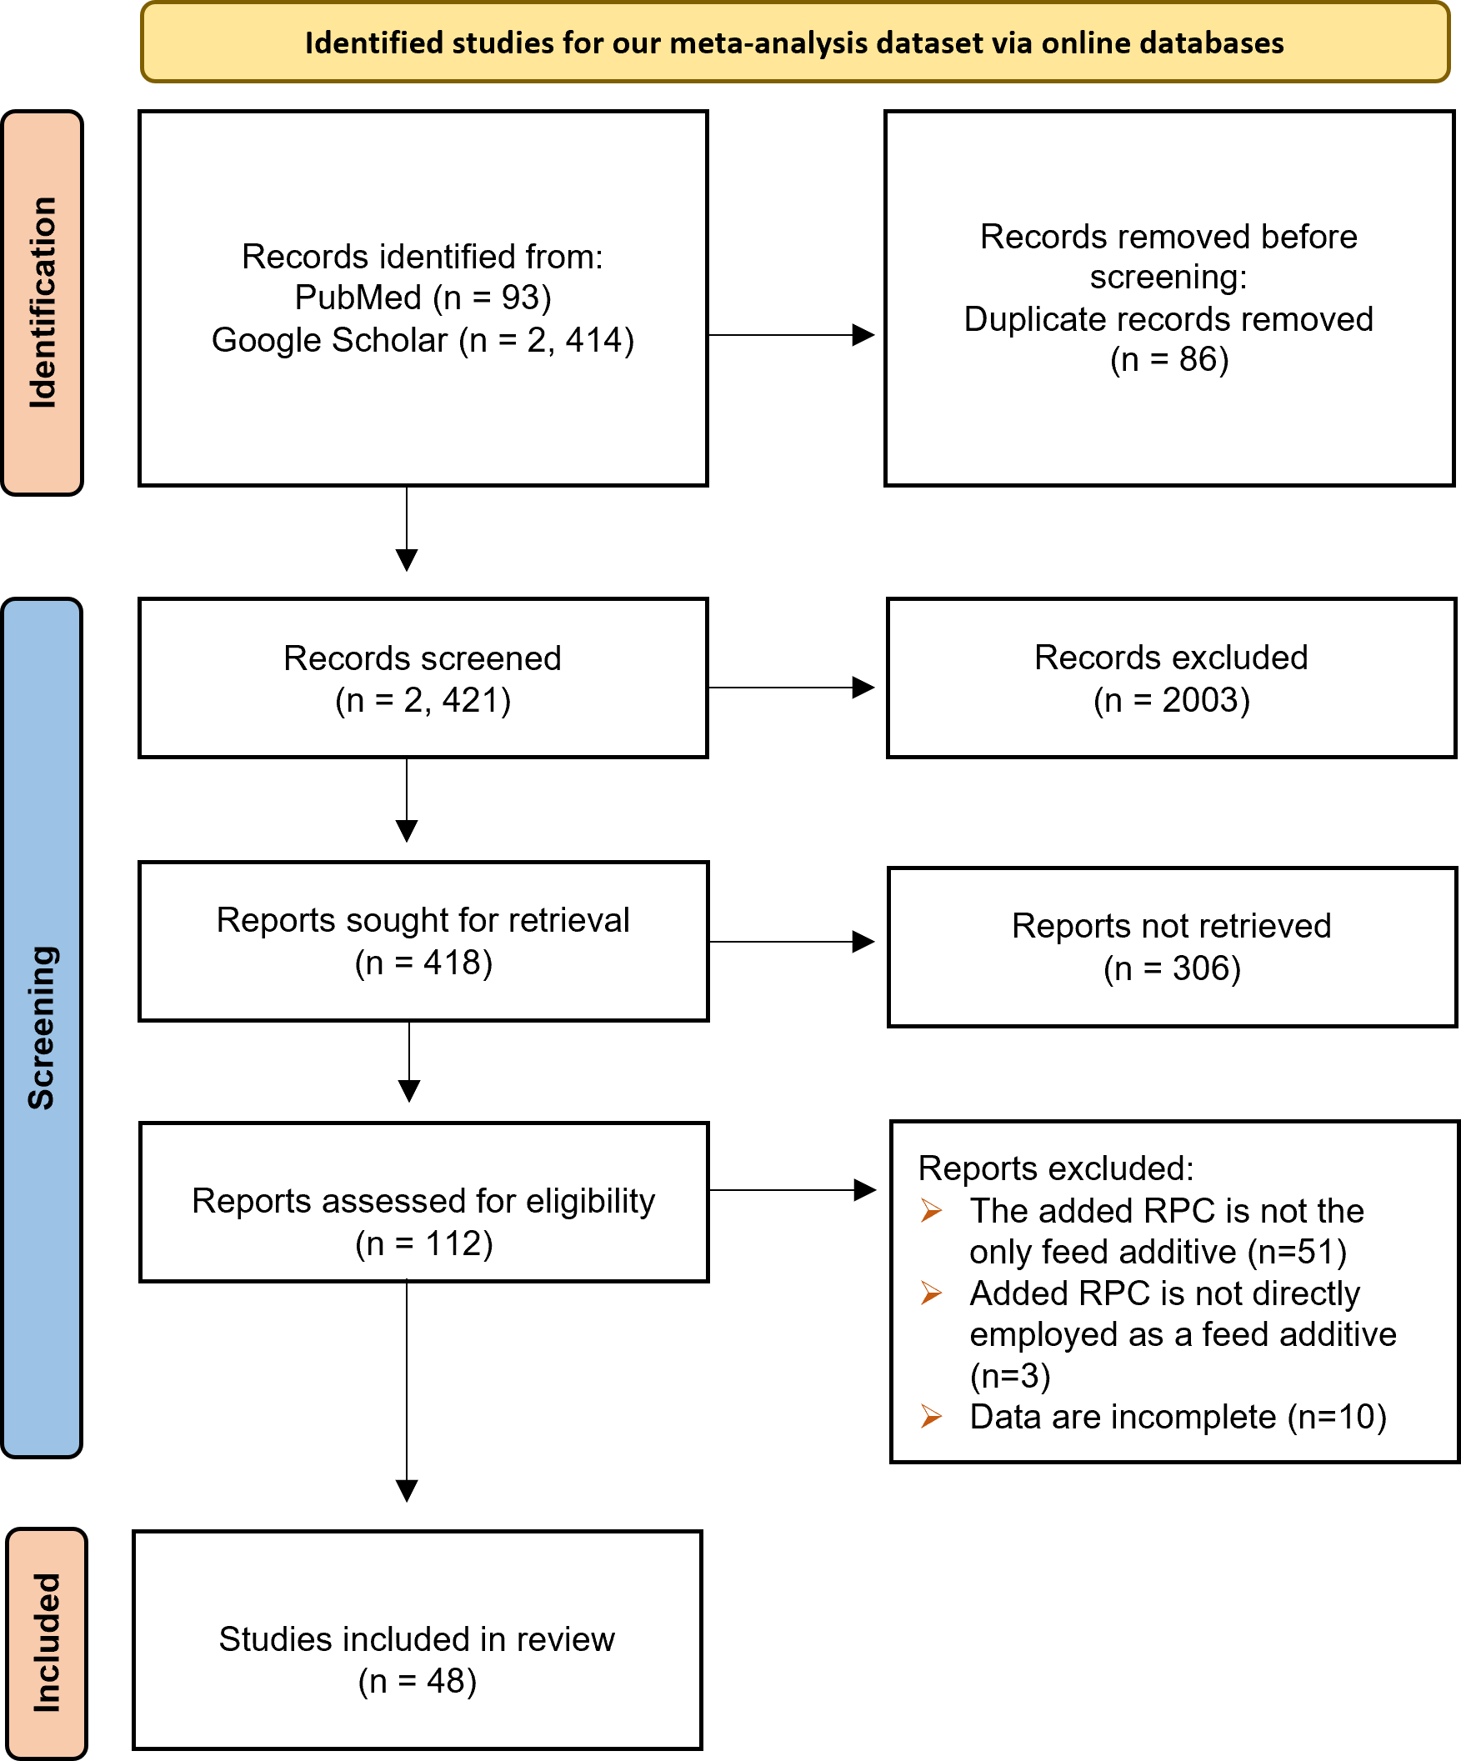
Fig. S1. Prisma Flowchart for Study Inclusion. An original search returned 2,536 studies. After a critical evaluation of abstracts and full texts, a total of 48 articles with 729 data entries were selected for database development.
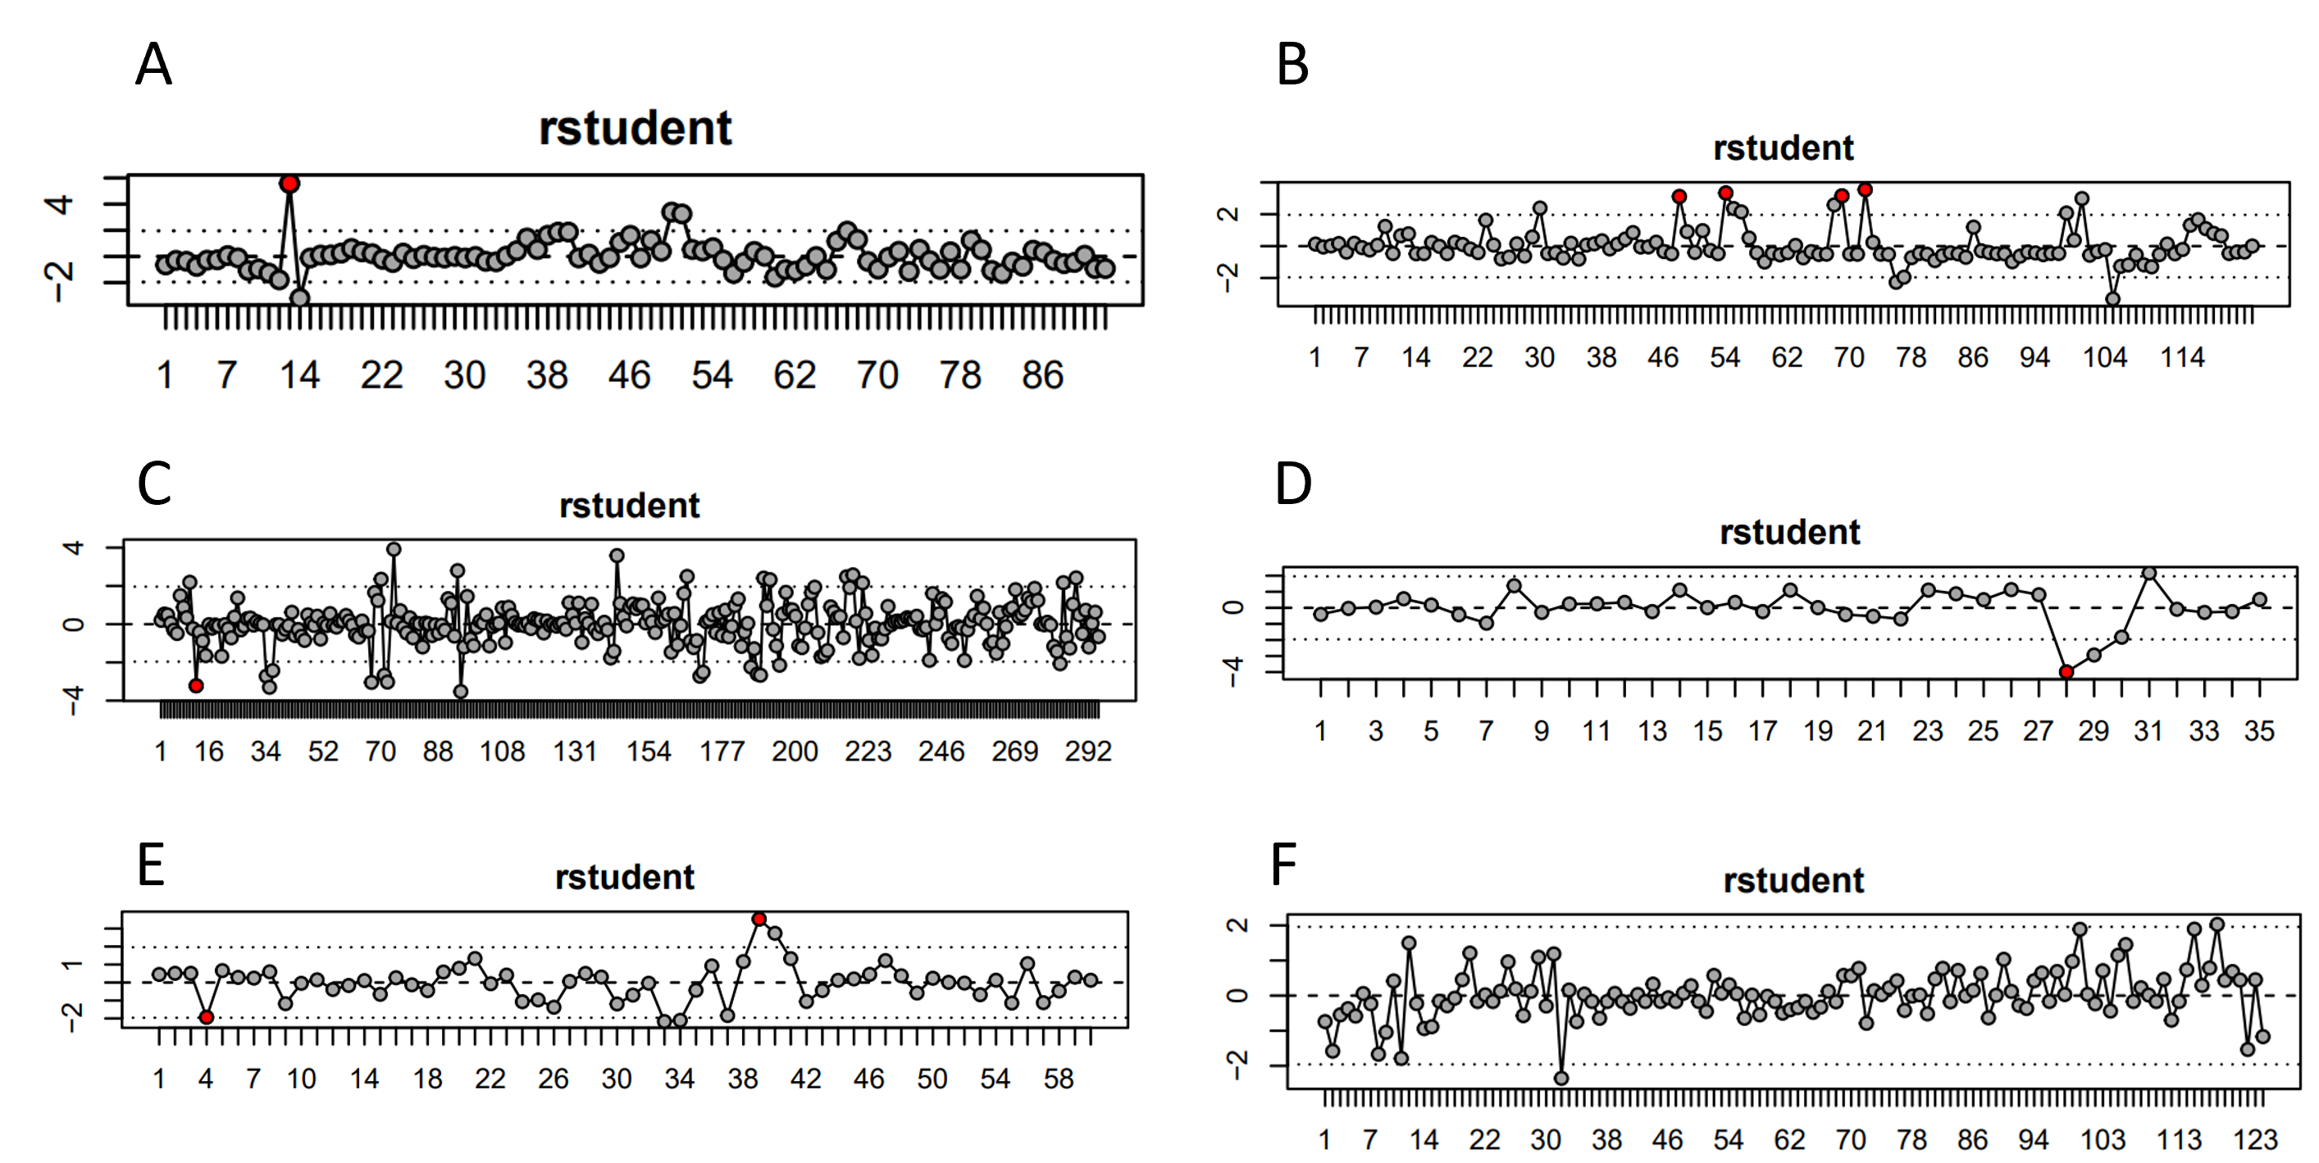
Fig. S2. Sensitivity analysis for impact-outlier diagnostic scatterplots for (A) growth, (B) production, (C) blood metabolites, (D) immunity, (E) liver composition, and (F) gene expression. Where the vertical axis represents the values of the rstudent for sensitivity analyses, and each dot corresponds to the value of one piece of data. Black dots indicate that the corresponding data is not anomalous and red dots indicate that the corresponding data is an outlier. 1, 4, 1, 1, and 2 outliers in the categories of growth, production, blood metabolism, liver composition, and immunity.

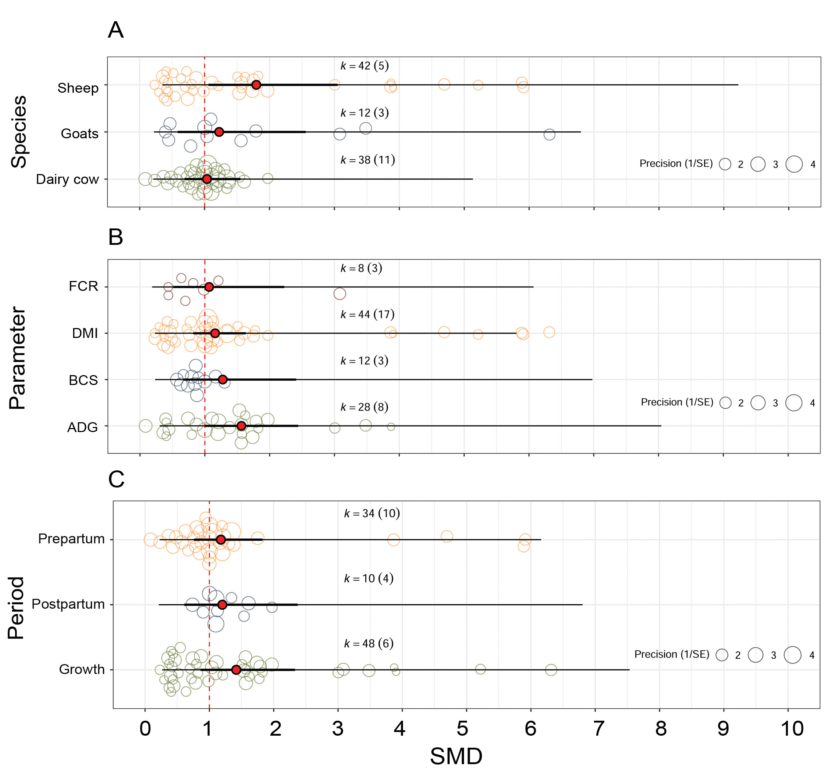
Fig. S3. Effects of rumen-protected choline (RPC) on growth performance. Orchard plots showing the moderator effects of RPC on (A) response parameters, (B) species, and (C) experimental period, with the standardized mean difference (SMD, Hedges’ g) used as the effect size. The thick error bars are 95% confidence intervals (CIs), indicating statistical significance, while the fine error bars are 95% prediction intervals (PIs), indicating the range within which 95% of effect sizes are expected to fall. K represents the number of effect sizes (SMD) derived from the pool of empirical studies. For example, K =26 (15) indicates that 26 effect sizes were calculated for growth based on 15 included studies. The dot at the center of each circle represents the mean effect size. A size scale for the circles is provided below the plot. FCR: feed conversion ratio, DMI: dry matter intake, BCS: body condition score, ADG: average daily gain.

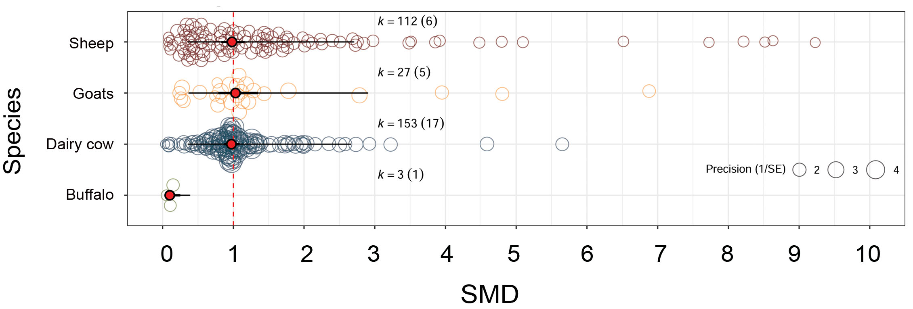
Fig. S4. Effects of rumen-protected choline (RPC) on species of blood metabolism. Orchard plots showing the moderator effects of RPC on species with the standardized mean difference (SMD, Hedges’ g) used as the effect size. The thick error bars are 95% confidence intervals (CIs), indicating statistical significance, while the fine error bars are 95% prediction intervals (PIs), indicating the range within which 95% of effect sizes are expected to fall. K represents the number of effect sizes (SMD) derived from the pool of empirical studies. For example, K =112 (6) indicates that 112 effect sizes were calculated for growth based on 6 included studies. The dot at the center of each circle represents the mean effect size. A size scale for the circles is provided below the plot.

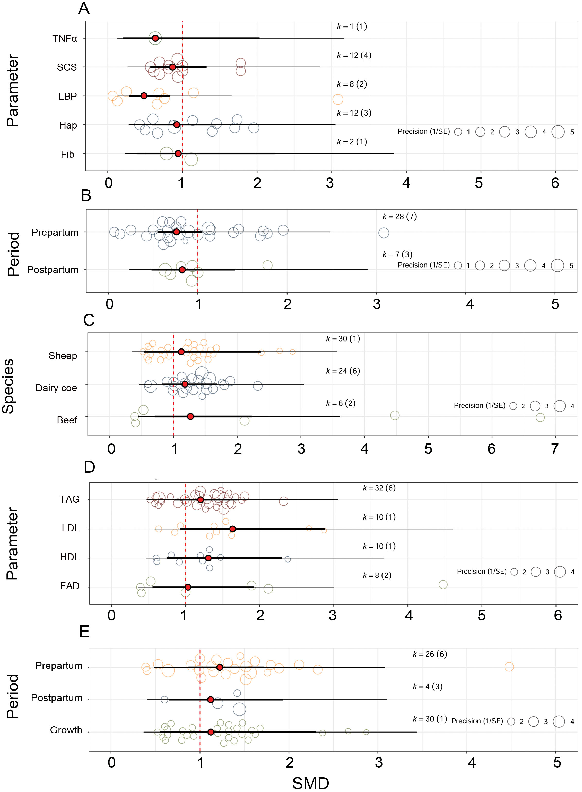
Fig. S5. Effects of rumen-protected choline (RPC) on immunity and liver composition. Orchard plots showing the moderator effects of RPC on (A) response parameters of immunity, (B) period of immunity, (C) species of liver composition, (D) response parameters of liver composition, and (E) period of liver composition with the standardized mean difference (SMD, Hedges’ g) used as the effect size. The thick error bars are 95% confidence intervals (CIs), indicating statistical significance, while the fine error bars are 95% prediction intervals (PIs), indicating the range within which 95% of effect sizes are expected to fall. K represents the number of effect sizes (SMD) derived from the pool of empirical studies. For example, K =26 (15) indicates that 26 effect sizes were calculated for growth based on 15 included studies. The dot at the center of each circle represents the mean effect size. A size scale for the circles is provided below the plot. TNFα: tumor necrosis factor alpha; SCS: somatic cell score; LBP: lipopolysaccharide binding protein; Hap: haptoglobin; Fib: fibrinogen; TAG: triacylglycerol; LDL: low-density lipoprotein; HDL: high-density lipoprotein; FAD: flavin adenine dinucleotide.

